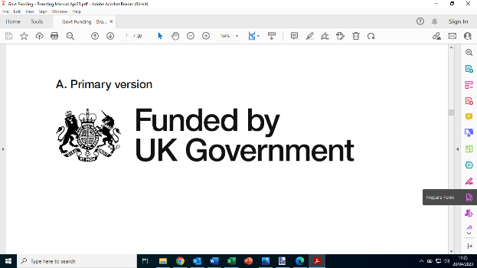 | 




Subsidy Control Declaration

This award shall comply with the Subsidy Control Act on the basis that, including this support no single business shall receive funding / support totalling more than €315,000 from public funds over a 3-year period covering the current financial year and the preceding 2 years.

Please use the table below to declare relevant subsidies received.

Small Amounts of Financial Assistance Allowance

I confirm that I have previously received the following subsidies granted as de minimis aid or as Small Amounts of Financial Assistance under the Subsidy Control Act 2022 during the current and two previous fiscal years from any subsidy awarding body:
(Please also include any grant aid that has been awarded but not yet paid).

Organisation providing the assistance/aid | Value of assistance (£) | Date of assistance | Nature of assistance / aid

You may need to declare these amounts to any other subsidy awarding body who requests information from you on how much subsidy you have received. You must therefore retain this letter and produce it on any request from the UK public authorities.

Name of Business:
Business Representative
Name/ Position:
Signature: |  | Date:

