The LEADER 5 area
The LEADER 5 area covers all of Torridge and North Devon, excluding the urban area of Barnstaple. This is because the funding is aimed at rural areas and Barnstaple has been deemed as ineligible due to its population size. The approximate boundary of the excluded area Barnstaple can be found here

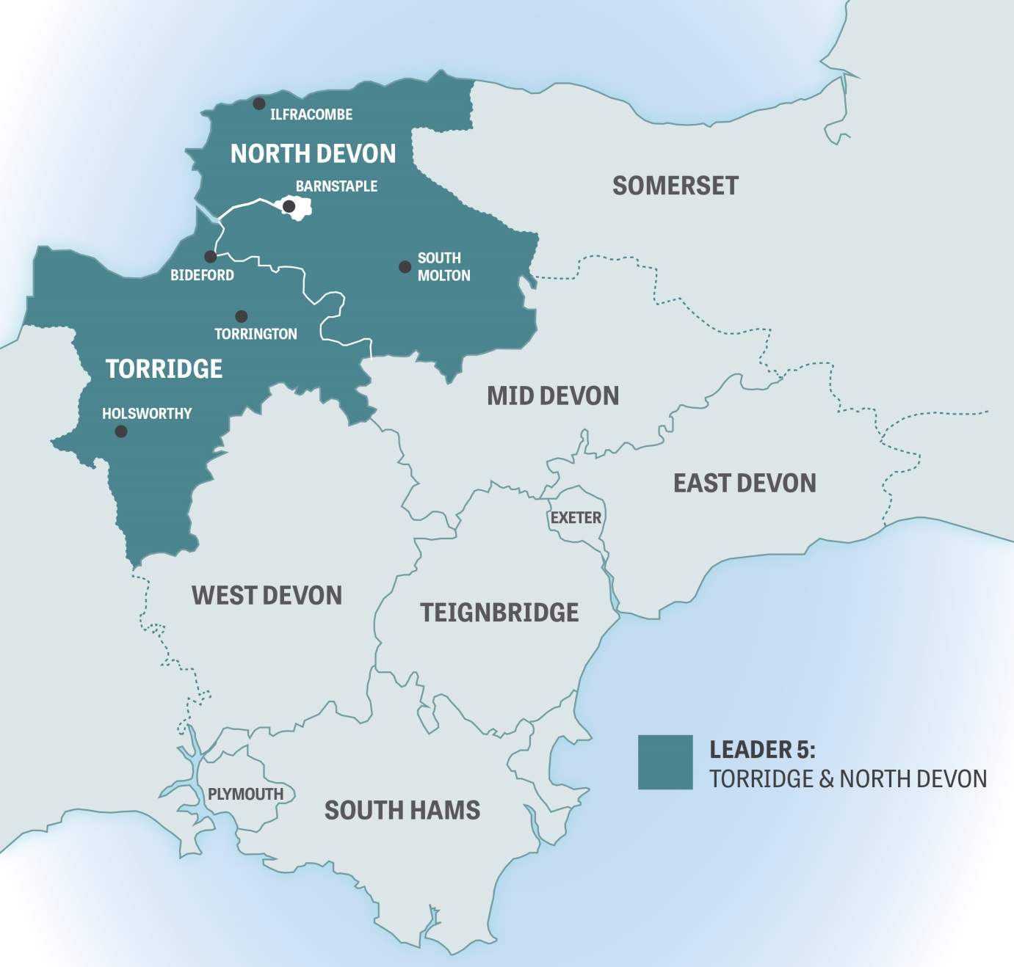

If you are uncertain whether you are within the LEADER 5 area, please get in contact with the team and they will be able to check for you. To do this, email your address and postcode to leader5@northdevonplus.co.uk or ring 01237 426423

